 |  | PROJECT NO: AATPO-2604071 |  |  |  |  |  | 
PROJECT:
REINFORCEMENT SCADA AETRA AIR TANGERANG
PT. AETRA AIR TANGERANG |  | Date: 18 Agustus 2026 |  |  | DAILY REPORT No: 059 |  |  | PT. REKAYASA TEKNOLOGI UTAMA
 |  |  |  |  | WEEK No: 14 |  |  | PT. REKAYASA TEKNOLOGI UTAMA
No. | NAME |  | QUALIFICATION |  | Working hours |  | Remarks | Extra job
1. | Ridho Nurlanang F. |  | Engineer |  | 8
2. | Reinhold S. B. P. |  | Engineer |  | 8
Total Manpower: 2
No. | MAIN EQUIPMENT |  |  |  | Quantity
1. | Mini bus |  |  |  | 1
2. | Mechanical tools package |  |  |  | 1
3. | Electrical tools package |  |  |  | 1
4. | Drilling machines |  |  |  | 1
5. | Cutting tools and accessories |  |  |  | 1
6. | Personal Safety Equipment |  |  |  | 1
Work Description:
08:00 Am: Arrival to the site
Activities done this day:
- Toolbox Meeting  - Troubleshooting penarikan data modbus vsd twps  - Troubleshooting modbus sensor vibrasi twps  Note:  Work Evaluation: |  |  |  | Documentation:  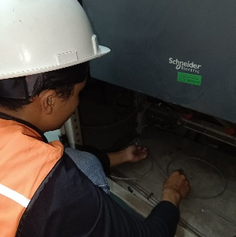  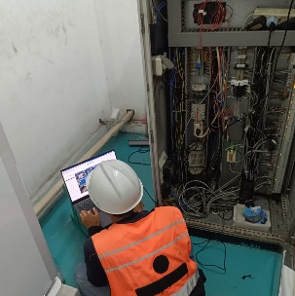  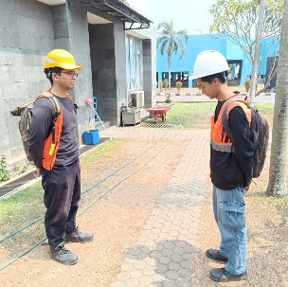  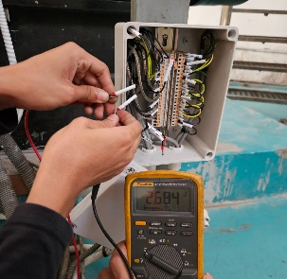  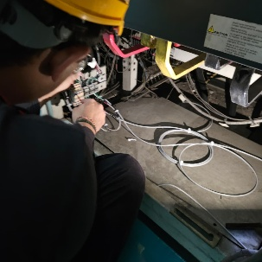  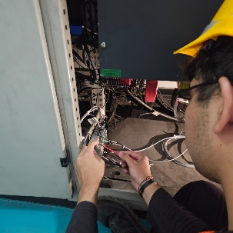
Activities planned for next Shift:
17:00 Pm: Leave site
PT. Rekayasa Teknologi Utama |  |  |  |  |  | PT. Aetra Air Tangerang
  Signature: Reinhold Samuel B Pardede : 18 Agustus 2026 |  |  |  |  |  | Signature: Date:

